**Stata open sample dataset for workshop**

**Open Data Using Command Window, Copy and Paste**

* Sign in to Apps on Demand. [Written Instructions](https://docs.google.com/document/d/1Px8NWoKpV4onrthao60ZpX2NrbAec89j/edit?usp=sharing&ouid=117340435050962348521&rtpof=true&sd=true), [video instructions](https://www.youtube.com/watch?v=j-8-wAb6MZY)
* Open Stata software
* [Copy and Paste](https://it.cornell.edu/appsondemand/copy-and-paste-non-chrome-browsers-apps-demand#:~:text=Copy%20from%20a%20Local%20App%20to%20Paste%20into%20an%20Apps%20On%20Demand%20App,-Back%20to%20Top&text=on%20Demand%20session.-,In%20the%20AppStream%20navigation%20bar%2C%20click%20the%20Clipboard%20icon%2C%20then,fade%20and%20exit%20your%20screen.) command below into “Command’ window as seen in screenshot. Press ‘enter’ to run command and open dataset.

sysuse auto, clear

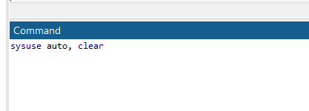

**Open Data using File**

* Sign in to Apps on Demand. [Written Instructions](https://docs.google.com/document/d/1Px8NWoKpV4onrthao60ZpX2NrbAec89j/edit?usp=sharing&ouid=117340435050962348521&rtpof=true&sd=true), [video instructions](https://www.youtube.com/watch?v=j-8-wAb6MZY)
* Open Google Chrome from WITHIN Apps on Demand.

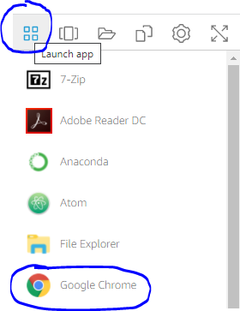

* Use link below to access and download dataset. This will download to “Downloads” folder. Pasting into Apps on Demand session can be tricky. Use following link to understand how to copy and paste within Apps on Demand. [Copy and Paste in Apps on Demand](https://it.cornell.edu/appsondemand/copy-and-paste-non-chrome-browsers-apps-demand?utm_source=sidebar)

<https://drive.google.com/file/d/1wzSh_cev7ByalW0jNRekUygKg5HVNFFA/view?usp=sharing>

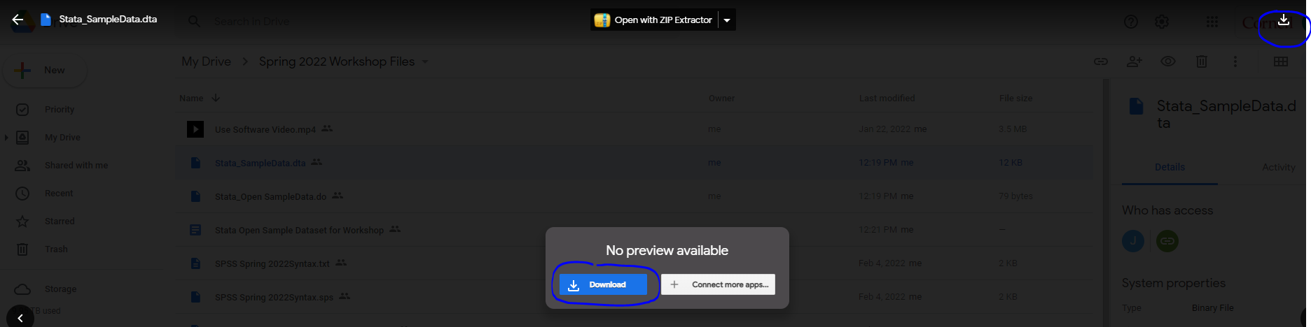

* Open Stata
* File -> Open -> Find location of where you downloaded data file.

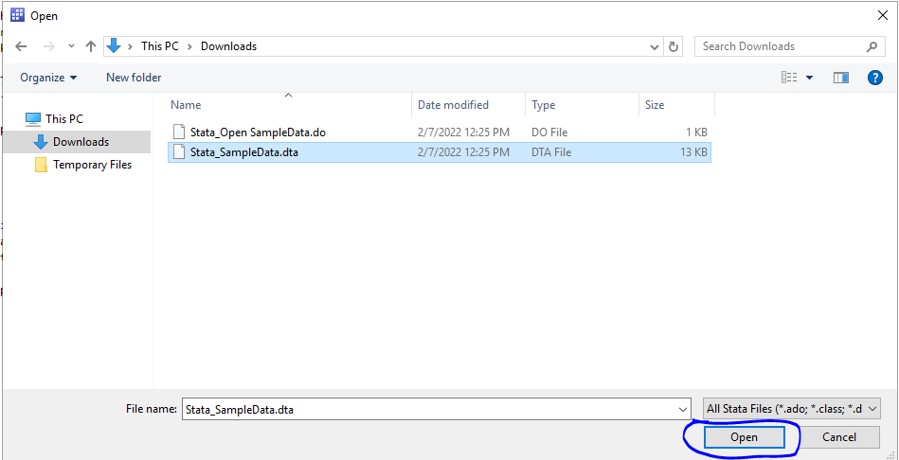

* Upon pressing enter, dataset will open.

**Open Data using Syntax**

* Sign in to Apps on Demand. [Written Instructions](https://docs.google.com/document/d/1Px8NWoKpV4onrthao60ZpX2NrbAec89j/edit?usp=sharing&ouid=117340435050962348521&rtpof=true&sd=true), [video instructions](https://www.youtube.com/watch?v=j-8-wAb6MZY)
* Open Google Chrome from WITHIN Apps on Demand.



* Use link below to access and download dataset. This will download to “Downloads” folder. Pasting into Apps on Demand session can be tricky. Use following link to understand how to copy and paste within Apps on Demand. [Copy and Paste in Apps on Demand](https://it.cornell.edu/appsondemand/copy-and-paste-non-chrome-browsers-apps-demand?utm_source=sidebar)

<https://drive.google.com/file/d/193swKqEgypBCjKoiseGlkVyqqEafy8Wh/view?usp=sharing>

* Open Stata
* File -> Open -> Find location of where you downloaded .do file

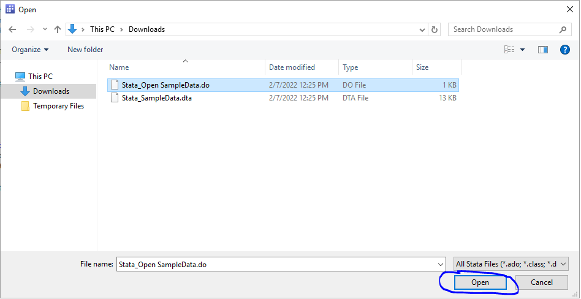

* New window opens. Click Play icon to run syntax and open dataset.

